Development of digital skills of the unemployed aged over 50
Erasmus+ Project KA2

5th project meeting in Pécs / Hungary from 23th to 24th February 2018

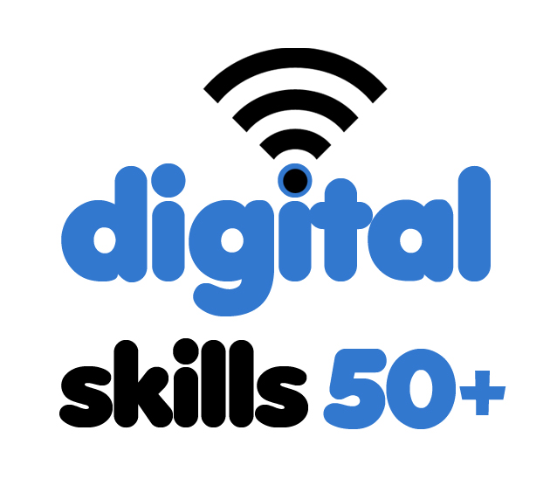 | Newsletter No 5 23/2/2018  The aim of the project is the exchange of experiences between the partners about effective ways of the digital inclusion of unemployed persons aged 50+, by motivating them to use new technologies in order to improve their situation in the labour market, overcome the fear of using of information technology and organize activities promoting digital literacy.  Partners of the project:  - BOIE Ltd (Poland) www.boie.pl  - AKLUB (the Czech Republic) www.aklub.org  - NHE / ECA (Hungary) www.ckh.hu  - The Elephant: Learning in Diversity B.V  (the Netherlands) www.the-elephant.nl
The 5th transnational project meeting took place in Pécs/Hungary, where is established NHE,  HUngarian partner of this project.  Most important issues of this meeting :  - Piloting phase – last discussion about the trainings; focus on the final development of the Training Modules and Pilot Training strategy  - Evaluation of last meeting in Krnov  - Final conference preparation.  Next transnational meeting will take place in Lodz (Poland) in April 16. | 